DIGITS
KS1 – 2002 Papers
1.
KS1 – 2003 Paper 2
2.
KS1 – 2004 Paper 1
3.
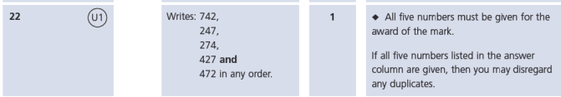
KS1 – 2004 Paper 2
4.
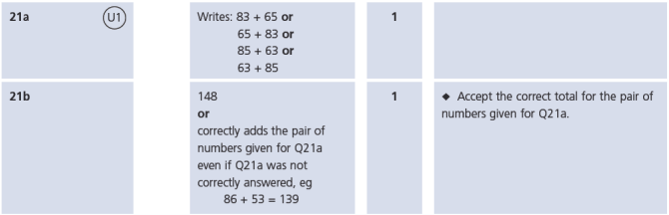
KS1 – 2016 Paper - Reasoning
5.
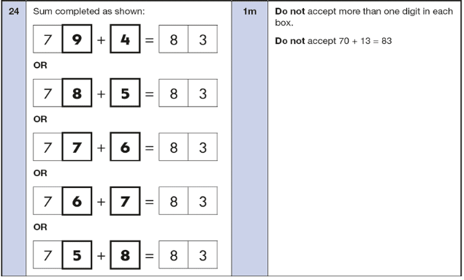
KS1 – 2019 Paper – Reasoning
6.
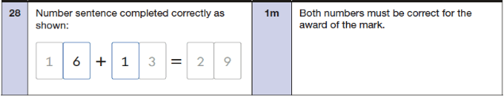
KS1 – 2022 Paper – Reasoning
7.
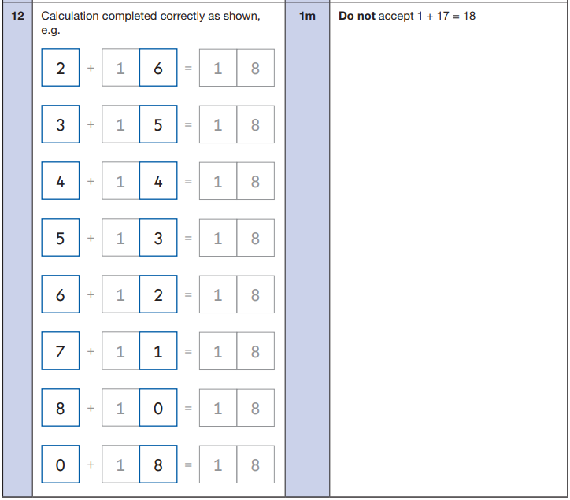
8.
